**Deep learning model for needle electromyography**

**electro-diagnosis in comparison with physicians:**

**A retrospective study**

**Ilhan Yooa†, Jaesung Yoob†, Dongmin Kimc, Ina Yound, Hyodong Kima, Michelle Youna, Jun Hee Wone, Woosup Choe, Youho Myonge, Sehoon Kime, Ri Yue, Sung-Min Kimf, Kwangsoo Kimg, Seung-Bo Leeh* and Keewon Kime\***

a Department of Neurology, Nowon Eulji Medical Center, Eulji University School of Medicine, Seoul, Republic of Korea

b School of Electrical Engineering, Korea University, Seoul, Republic of Korea

c Biomedical Research Institute, Seoul National University Hospital, Seoul, Republic of Korea

d Department of Computer Science, New York University, New York, USA

e Department of Rehabilitation Medicine, Seoul National University Hospital, Seoul, Republic of Korea

f Department of Neurology, Seoul National University Hospital, Seoul National University College of Medicine, Seoul, Republic of Korea

g Transdisciplinary Department of Medicine & Advanced Technology, Seoul National University Hospital, Seoul, Republic of Korea

h Department of Medical Informatics, Keimyung University School of Medicine, Daegu, South Korea

† These Authors contributed equally to this work.

* Co-corresponding authors

**Address for Correspondence**

Keewon Kim, MD, PhD

Department of Rehabilitation Medicine, Seoul National University Hospital, 101, Daehak-ro, Jongno-gu, Seoul, Republic of Korea

Tel: +82-2-2072-0744

Fax: +82-2-6072-5244

E-mail: keewonkimm.d@gmail.com

**And**

Seung-Bo Lee, PhD

Department of Medical Informatics, Keimyung University School of Medicine, Daegu, South Korea

Tel: +82-10-8840-9483

E-mail: koreateam23@gmail.com

**Abstract**

**Background**

Electromyography (EMG) plays an important role in diagnosis of the neuromuscular disease by identifying the characteristic abnormalities of waveform. However, it has some limitations in that there are some discrepancies of electro-diagnosis results among physicians, and the accuracy of electro-diagnosis of EMG quite relies on the experience of physicians. To overcome these limitations of EMG, we investigated whether the deep learning approach can better classify EMG waveforms into the neuropathy, myopathy, and normal than physicians’ electro-diagnosis results.

**Methods and findings**

Needle EMG data (58 patients; 382 muscles) stored in Seoul National University Hospital database from June 2015 to July 2020 was used. The one-dimensional convolutional neural network model was used as the deep learning model. The deep learning model and the six physicians classified and electro-diagnosed the EMG waveforms into myopathy, neuropathy, and normal, respectively.

The accuracy, sensitivity, specificity, positive predictive value and F1 score of the deep learning model were 0.720, 0.715, 0.858, 0.726, and 0.715, respectively; and those averaged of physicians were 0.537, 0.527, 0.770, 0.582, and 0.511, respectively. The performances of deep learning model for predicting myopathy, neuropathy, and normal were also evaluated with area under the receiver operating characteristic curve, and the results were 0.874 (95% confidence interval [CI] 0.858–0.889), 0.781 (95% CI 0.723–0.839), and 0.847 (95% CI 0.836–0.858), respectively.

**Conclusions**

This study demonstrated that the deep learning could contribute to interpreting the EMG of the patient with neuromuscular disease on behalf of physicians and assisting physician’s decision-making in diagnosing patient with neuromuscular disease. Large, prospective cohort studies with more diverse neuromuscular diseases will further improve the performance of the deep learning-based EMG interpretation in the future.

**Keywords**: Electromyography, Machine learning, Neuromuscular disease, Deep learning, Convolutional neural network**Author summary**

**Why was this study done?**

* Electromyography (EMG) has been established as an important electro-physiologic test that is widely performed when diagnosing patient with neuromuscular disorder.
* Despite the importance of EMG in diagnosis, the accuracy of EMG electro-diagnosis is not precise enough and there are often discrepancies among examiners. Therefore, more objective and accurate method is needed.
* Although EMG in volitional state plays important role in diagnosing neuromuscular disease, previous studies have mainly focused on analysis of gestures using the surface EMG or analysis the abnormal spontaneous activities from needle EMG during a resting state. Therefore, additional research is needed for clinical application of deep learning-based electro-diagnosis of neuromuscular disease.

**What did the researchers do and find?**

* The EMG data from 58 patients were used. The patients were classified into myopathy, neuropathy, or normal by the deep learning model and were electro-diagnosed as one of myopathy, neuropathy, or normal by the physicians. After, classification and electro-diagnosis, the classification result by the deep learning model was compared with electro-diagnosis results by physicians neurologists and rehabilitation medicine doctors.
* The accuracy of classifying EMG data by our deep learning model was 0.720, and the average accuracy of electro-diagnosis by physicians was 0.537.
* The classification by our deep learning model was more accurate and faster than electro-diagnosis by physicians.

**What do these findings mean?**

* Deep learning could electro-diagnose EMG on behalf of a physician and could be used to assist a physician in diagnosing the patient with neuromuscular disease.
* The performance of deep learning could be further enhanced by carrying out large-scale prospective study including patients with more variable and specific kinds of neuromuscular disease.

**Introduction**

Electromyography (EMG) is an electrophysiological test that records electrical activity generated from nerves, muscles, and neuromuscular junctions through a needle inserted into the muscle or surface electrode during resting and volitional states [1-6]. Disorders of the peripheral nerves and muscles are identified with the abnormalities in EMG signals, which reflect the anatomical and physiological states of peripheral nerves and muscles [1-6].

The signal, which are recorded during muscle contraction, consists of motor unit action potential (MUAP) and can only be measured from muscles in a volitional state not in a resting state. Since EMG signals during a resting state cannot contribute to distinguishing between neuropathy and myopathy, MUAP is an essential key for physician to distinguish whether a patient has neuropathy or myopathy [1, 5-12]. Additionally, when the neuromuscular disease is in the early state or in a mild abnormal state, abnormal findings are found only in MUAP during a volitional state not during in a resting state [13, 14]. A patient with peripheral neuropathy commonly shows MUAP with high amplitudes, long durations, and reduced recruitments, whereas one with myopathy commonly exhibits MUAP with small amplitudes, short durations, and early recruitments on the EMG evaluation [1, 5-12]. Needle EMG (nEMG) is a type of EMG that uses needle as an electrode and is useful for recording the MUAPs from individual motor units and deep muscles [15].

Although EMG plays an important role in diagnosing normal, neuropathy or myopathy of a patient, there are some limitations. First, the accuracy of EMG diagnosis quite relies on the proficiency of the examiner. Previous studies have reported that sensitivity of EMG in the diagnosis of neuropathy, myopathy, and normal is 47–83%, specificity is 73–81% and inter-rater reliability is 62–81% [16-18]. Second, considerable time and effort is needed to abnormalities of EMG signals accurately. The prevalence of neuropathy and myopathy continues to rise which burdens physicians with increased number of EMG waiting to be electro-diagnosed. [19-22]. An accurate, efficient, and automated approach may be helpful in clinical diagnosis using the nEMG.

Recently, a deep learning has been used to analyzing big data in many fields, and it is also applied to clinical data including waveform, time series data such as electrocardiography, electroencephalography [23-26]. There have also been number of studies on deep learning in medical applications which the performance of the deep learning model was similar to or better than that of humans [27-30]. In previous studies, machine learning has been mainly used to analyze the abnormal spontaneous activities that present during a resting state or to analyze gestures that are not related to the diagnosis of neuromuscular diseases using the surface EMG [31-35]. To the best of our knowledge, few studies have been reported using machine learning to analyze nEMG signals during a volitional state.

To overcome the diagnostic limitations of EMG and investigate the feasibility of machine learning on nEMG during a volitional state, we developed the deep learning model that could classify the patient into myopathy, neuropathy or normal based on volitional state-nEMG signals. We retrospectively reviewed nEMG data of patients with peripheral neuropathy or myopathy as well as patients without any neuromuscular disease. The classification results by out deep learning model and electro-diagnosis results by 6 physicians were compared.

**Methods**

**Study design and preparation**

The nEMG signal data consisted of 58 patients who visited Seoul National University Hospital from June 2015 to July 2020. Each patient was labeled with one of peripheral neuropathy, myopathy, and normal based on the final diagnosis. This study was approved by the institutional review board of Seoul national university hospital (No. 2008-055-1147), and was conducted according to the Declaration of Helsinki and its later amendments. Informed consent was not necessary because this study was retrospective analysis and private information from all patients were anonymized before analysis.

The nEMG evaluation was performed with a Nicolet EDX EMG system and a monopolar needle electrode. The filter setting was set at 20 Hz (low-cut) and 10 kHz (high-cut). The nEMG signal was measured at sampling rate of 48 kHz. The results of the final 10 seconds during the nEMG were stored in EMG machine and used for analysis.

The certified neurologist and the certified rehabilitation medicine doctor reviewed the nEMG data and confirmed the diagnosis of all patients. After extracting the nEMG signal stored as numerical data in the EMG device, it was converted into waveform data using MATLAB software (version R2020b). Among the created waveform data, electromyographic artifacts which occurred during moves of the needle electrode or the patient, were removed at the beginning and at the end of EMG data; and then almost all the noise in the rest was preserved. Based on the elbow joint of the upper extremity and the knee joint of the lower extremity, muscles close to the trunk were labeled as proximal muscles and those far from the trunk as distal muscles.

**Electro-diagnosis by physicians**

A web-based nEMG signal labeling platform was developed to allow residents, who belonged to different institutions, electro-diagnose patients of this study. After de-identifying the patient information, the nEMG waveform data were displayed on the screen in a similar way the EMG data presented on the EMG device (S1 Fig).

Two residents of neurology and four residents of rehabilitation medicine watched the nEMG signal of the muscles examined for each patient and electro-diagnosed the patient as one of myopathy, neuropathy, and normal without clinical information other than nEMG results. When the physician clicked the anonymized patient id, the nEMG waveform data was presented on the screen along with the sound similar to the sound from the EMG device. The real-time waveform data was presented on the left, and the waveform data was stacked on the right for 500 microseconds. The physicians were allowed to change the voltage amplitude ticks of the screen among 100 μV, 200 μV, 500 μV, 1 mV, and 2 mV. Physicians first annotated each nEMG signal from different muscles, and then diagnosed the patients by considering the muscles annotation results. The electro-diagnosis results of physicians were stored within the platform.

**Classification by deep learning model**

The nEMG signals were down-sampled to 10 kHz to reduce computational complexity. Each data was partitioned into windowed segments with lengths of 0.4 second and hop sizes of 0.1 second. The length and the hop size of the windows were selected heuristically. After slicing, there were total of 3664, 2700, and 1706 segments from patients with neuropathy, myopathy, and normal patients, respectively.

A one-dimensional convolutional neural network (CNN) was used as the deep learning model [36]. The CNN was designed after the motives of ResNes and VGG, which are well-performing image classification models [37, 38]. The CNN comprised of 7 spatial reduction blocks, 5 residual blocks, and fully connected layers (S2 Fig). The spatial reduction block consisted of convolutional layers, batch normalization, rectified linear unit (ReLU), and max pooling. The residual block contained similar layers with an added residual connection [37]. The model receives raw signal segments and predicts the three class (myopathy, neuropathy, normal) probabilities.

Hyper-parameters were determined empirically with learning rate of 10-3, batch size of 32, and epoch of 100. Early stopping was performed by evaluating accuracy on the validation set every 30 updates, and the patience value was set to 100 [39]. Cross entropy loss was used as the loss function with class weights applied inverse proportionally to the number of signal segments from the train set. Deep learning performance was measured through 5*3-fold cross validation (5*3 CV) since there were small number of subjects.

The deep learning model used two stages to classify the patient; first, it received the multiple segments sliced from a single muscle’s nEMG data and returns the three-class probability of the segment being myopathy, neuropathy, or normal. The probabilities of the segments were averaged to produce a three-class probability of each muscle. After probabilities of all muscle from each patient are computed, feature vector was produced for the patient using the individual muscle probabilities. Two methods were compared to generate the feature vector. Another method was to average the muscle probabilities per muscle location label (proximal muscle or distal muscle) to produce six-dimensional vector. When patient did not have any muscle probability for some muscle location label, mean value of 1/3 was imputed to prevent undesired bias. The performance of deep learning model presented in this article are from averaging over all muscle probabilities. The second stage receives the feature vector generated and classifies the three-class diagnosis of the subject using a logistic regression classifier.

After the model was trained, an explainable artificial intelligence technique named feature visualization was applied to visualize the features which the model is focusing on [40]. The initial feature was sampled from gaussian distribution N (0,0.5), and random jitter was applied as regularization with 12.5% of the signal segment length. Learning rate was 10-2 and gradient descent updates were applied 3000 times.

**Assessing the results of the deep learning model and the physicians**

The performances of the deep learning model and the physicians were evaluated with following metrics: accuracy, F1 score, area under receiver operating characteristic curve (AUROC), positive predictive value (PPV; precision), sensitivity (recall), and specificity. Based on those metrics, we compared the result classified by two versions of deep leaning model with and without muscle location labels and averaged result by six physicians.

**Statistical analysis**

Statistical analyses were performed using R statistical software (version 4.1.0; R Foundation for Statistical Computing, Vienna, Austria) and Python programming language (version 3.6). The normality for continuous variables was assessed using the Shapiro-Wilk test. The differences among the groups for categorical variables were assessed using the Pearson’s χ2 test and those for continuous variables were assessed using the Kruskal–Wallis test. Data are expressed as means ± standard deviation for continuous variables and number (%) for categorical variables. The degree of agreement was calculated within physicians and the deep learning model, and is expressed with value of Fleiss kappa. All metrics except accuracy (F1 score, AUROC, PPV, recall, and specificity) were binary classification, so were measured by averaging each class metrics from one-versus-rest method.

**Results**

**Patients’ characteristics**

There were total of 20 patients without any neuromuscular disease, 19 patients with neuropathy including radiculopathy, motor axonal polyneuropathy, and motor neuron disease, and 19 patients with myopathy including muscular dystrophy and inflammatory myopathy. The number of nEMG data used for analysis was 124, 161, and 97 for myopathy, neuropathy, and normal, respectively. The rest of demographic characteristics are shown in Table 1.

Table 1. Demographic characteristics of subjects and their needle electromyography data

|  |  |  |  |  |
| --- | --- | --- | --- | --- |
|  | Myopathy | Neuropathy | Normal | p-value |
| Number of patients | 19 | 19 | 20 |  |
| Female, n (%) | 14 (73.7) | 12 (63.2) | 13 (65) | 0.761 |
| Age (mean±SD) | 52.2±20.1 | 58.4±15.1 | 60.2±16.9 | 0.329 |
| Number of nEMG data according to location of muscle (%) | <0.001 | | | |
| Distal muscles | 60 (48.4) | 97 (60.2) | 80 (82.5) |  |
| Proximal muscles | 64 (51.6) | 64 (39.8) | 17 (17.5) |  |
| Number of nEMG (mean±SD) | 6.53±3.82 | 8.47±4.59 | 4.85±1.93 | 0.006 |
| Total signal length (sec) | 313.54 | 423.12 | 204.31 |  |

nEMG=needle electromyography

data are expressed in mean±standard deviation.

**Performance results of deep learning and physicians**

The classification performance of deep learning algorithm was compared to electro-diagnosis results of physicians using following metrics: the accuracy, sensitivity, specificity, PPV, and F1 score. Sliced segments less than 0.4 seconds were excluded because the deep leaning model only receives segment longer than 0.4 seconds; total of 8 patients and 10 muscle nEMG data were excluded from analysis because these were not annotated by either the physicians or the deep learning model. The results of the deep learning model that did not use muscle location information are presented as the above-mentioned metrics: the accuracy, sensitivity, specificity, PPV, and F1 score are 0.720±0.040, 0.715±0.050, 0.858±0.023, 0.726±0.032, and 0.715±0.044, respectively. The counterparts of physicians were 0.537±0.069, 0.527±0.069, 0.770±0.034, 0.582±0.076, and 0.511±0.084, respectively (Table 2), The degree of agreement, expressed in Fleiss κ, between physicians was 0.26 and between physicians and deep learning model was 0.26 (Table 3).

Table 2. The electro-diagnosis results by physicians and classification results by the deep learning model

|  |  |  |
| --- | --- | --- |
|  | Physicians (95% CI) | Deep learning model (95% CI) |
| Accuracy | 0.537 (0.491–0.583)* | 0.811(0.682–0.758)† |
| Sensitivity (recall) | 0.527(0.480–0.573)* | 0.720(0.668–0.762)† |
| Specificity | 0.770(0.747–0.793)* | 0.853(0.836–0.879)† |
| Posivie predictive value (PPV, Precision) | 0.582(0.530–0.633)* | 0.725(0.695–0.757)† |
| F1 score | 0.511(0.455–0.568)* | 0.715(0-.673–0.757)† |

* Average results of electro-diagnosis by 6 physicians

† Average results of classification by 3 deep learning models

The metrics except for accuracy are average of binary classification scores for each class from one-versus-rest method.

95% CI=95% confidence interval

Table 3. Degree of agreement between physicians and the deep learning model*

|  |  |  |
| --- | --- | --- |
|  | Physicians | Convolutional neural network |
| Overall | 0.260† | 0.256‡ |
| Myopathy | 0.360† | 0.400‡ |
| Neuropathy | 0.256† | 0.247‡ |
| Normal | 0.204† | 0.165‡ |

* data are expressed in Fleiss κ

† Fleiss κ value between the results by 6 physicians

‡ Fleiss κ value between the results by 6 physicians and deep learning model

Per-class ROC curves and precision-recall curves of the deep learning model were measured and depicted; for comparison, electro-diagnosis results of individual physician and averaged physician were measured and depicted in terms of sensitivity, specificity, and positive predictive value on Fig 1. The per-class physicians results for myopathy and neuropathy were placed near ROC curve and precision-recall curve of the deep learning model. The deep learning model outperformed when classifying normal patients. The AUROC of deep learning model classification result per class was 0.874 (95% confidence interval [CI] 0.858–0.889), 0.781 (95% CI 0.723–0.839), and 0.906 (95% CI 0.899–0.913) for myopathy, neuropathy, and normal, respectively.

Fig 1. Per-class receiver operating characteristic and precision-recall curves of the deep learning model and six physicians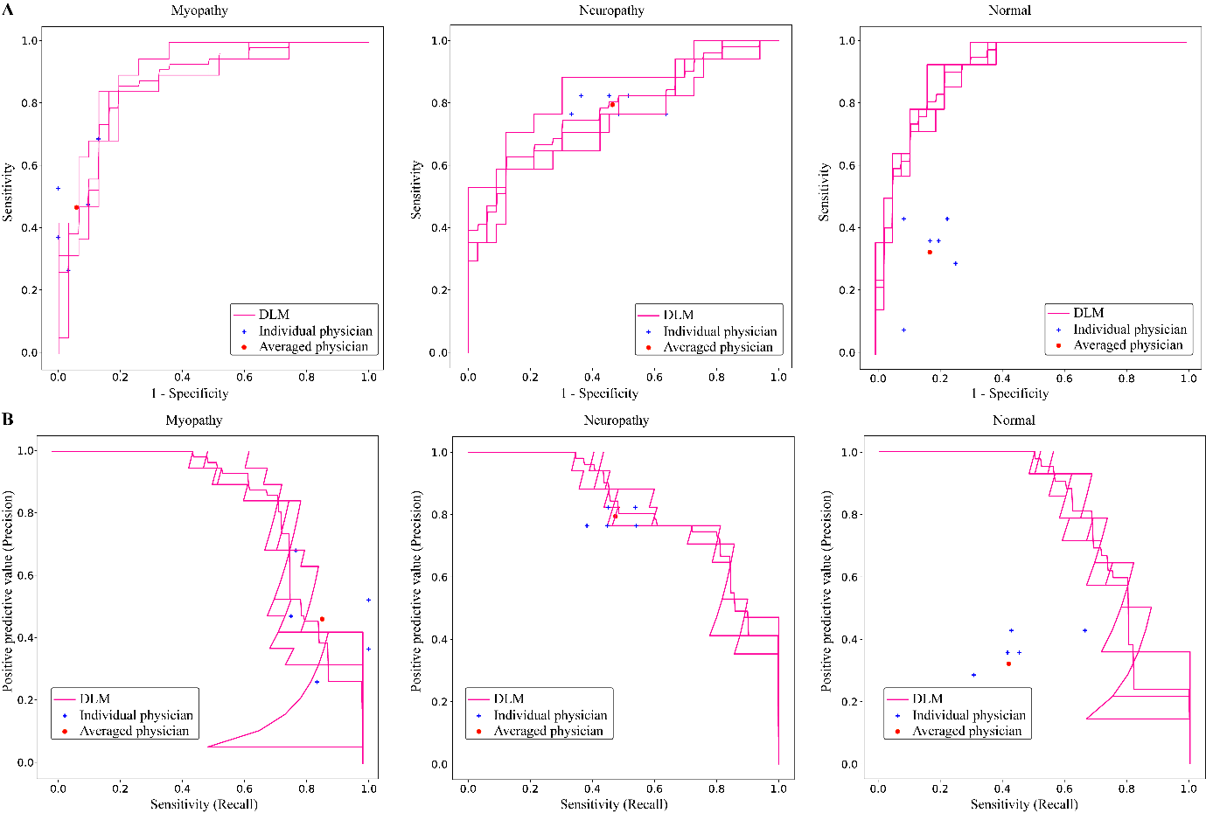

DLM= Deep learning model

A. Area under receiver operating characteristic curve (A) and precision-recall curve (B) was measured and depicted by dividing all data into myopathy, neuropathy, and normal.

Individual physician performance is annotated by the blue cross and averaged physician performance is annotated by the red dot.

From the confusion matrix of physicians and the deep learning model, the overall prediction pattern was identified (Fig 2). The correctly predicted ratios for myopathy, neuropathy, and normal by the deep learning model were 80.70%±4.96%, 64.71%±4.80%, and 69.05%±12.14%, respectively; the correctly electro-diagnosed ratios for myopathy, neuropathy, and normal by the physicians were 49.49%±13.04%, 79.41%±2.94%, and 32.14%±12.20%, respectively. The deep learning model outperformed physicians in predicting myopathy and normal, and was inferior in predicting neuropathy.

Fig 2. Confusion matrices of (A) physician electro-diagnosis results and (B) the deep learning model prediction results

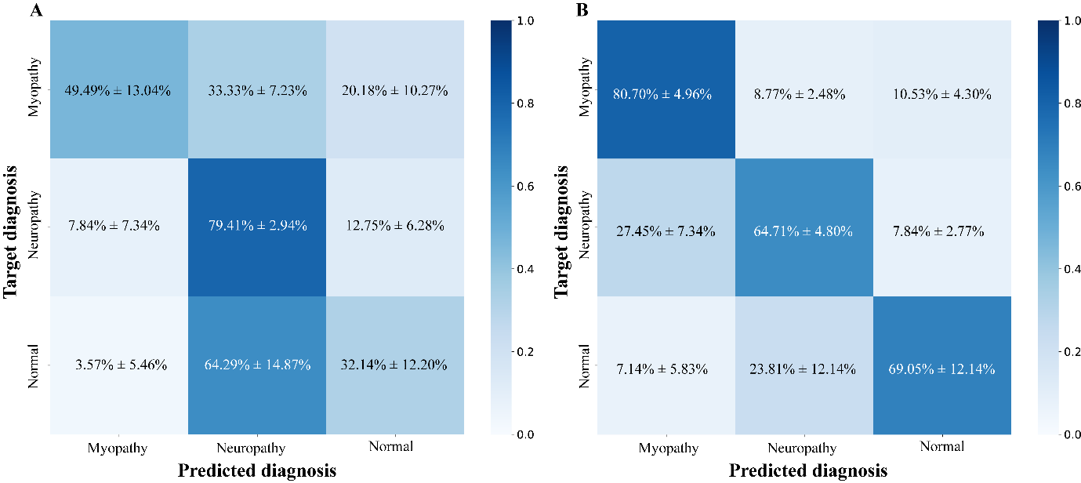

**Performance of the machine learning model considering the muscle location information**

The performances of deep learning model did not change significantly when muscle location information was added. The accuracy, sensitivity, specificity, PPC, and F1 score of the deep learning model considering the muscle location information were 0.700±0.053, 0.698±0.048, 0.848±0.026, 0.703±0.058, and 0.694±0.049, respectively (S1 Table). The AUROC of the same deep learning model were 0.841 (95% CI 0.811–0.871), 0.736 (95% CI 0.731–0.741), and 0.792 (95% CI 0.719–0.864) for myopathy, neuropathy, and normal, respectively (S3 Fig). The correctly predicted ratios for myopathy, neuropathy, and normal were 80.70%±8.95%, 54.90%±2.77%, and 73.81%±3.37%, respectively (S4 Fig). From the The prediction accuracies of CNN with muscle location information and those of CNN without muscle location information were as follows; the former and latter results for myopathy, neuropathy, and normal were 80.70%±8.95%, 54.90%±2.77%, 73.81%±3.37%, and 80.70%±4.96%, 64.71%±4.80%, 69.05%±12.14%, respectively (S4 Fig).

**Mispredicted cases of the machine learning model**

The cases which CNN algorithm predicted wrongly were analyzed, and among them, there were cases that CNN algorithm predicted incorrectly but more than two-thirds of the physicians predicted correctly as well as cases that both the physicians and CNN algorithm predicted incorrectly. The examples of aforementioned waveform are shown in S5 Fig.

**Created waveforms by the machine learning model**

The learned features were similar to the typical characteristics of neuropathy, myopathy, and normal. The waveform most likely to be predicted as myopathy and neuropathy showed small amplitudes as well as short durations (Fig 3A,B) and high amplitudes as well as long durations, respectively (Fig 3C,D).

Fig 3. Created waveforms by the machine learning model

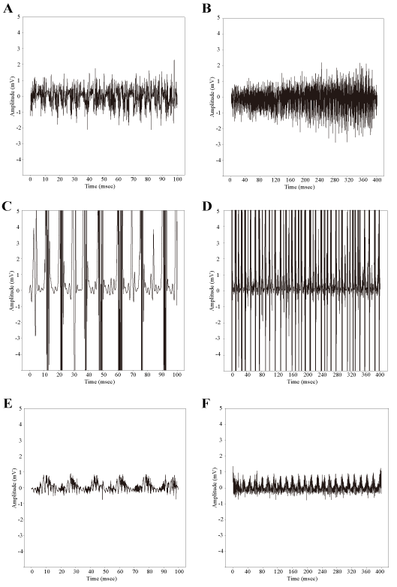

A and B, Myopathy; C and D, Neuropathy; E and F, Normal.

Note that A, C, E were plotted with 10 milli seconds of x-axis interval and B, D, F were plotted with 40milli seconds of x-axis interval to show the recruitment and interference pattern of overall waveforms.

**Discussion**

The aim of the present study was to validate the diagnostic performance of the machine learning using nEMG signals in a volitional state whether machine learning could support physician’s decision for more accurate and efficient diagnosis. For that purpose, deep learning was used to classify the nEMG signals into myopathy, neuropathy, and normal; and the classified results were compared with electro-diagnosis results by six physicians. Results demonstrated that our deep learning model outperformed electro-diagnosis results of physicians in all performance scores, including the accuracy which was 0.720±0.040 for the deep learning model and 0.537±0.069 for the physicians.

There have been reports that machine learning showed good performance when applied to analyzing EMG signals. [31-35] However, previous studies on EMG have been mainly focused on abnormal spontaneous activities in a resting state, and the signals were preprocessed to form two-dimensional features which may increases computational complexity. [33, 34] It has been well known that the EMG evaluation is important in the diagnosis of the neuromuscular disease; and EMG signals during a volitional state play an essential role in differentiating myopathy, neuropathy, normal as well as identifying the neuromuscular disease in the initial state or the minimally involved state. [1-6, 8, 13, 14, 41]. To the best of our knowledge, there have been few studies that analyze the EMG data during a volitional state using a deep learning. We analyzed nEMG signal in volitional state, which is important for electro-diagnosis of neuropathy and myopathy, and confirmed that it showed better performance than physicians.

In order to finally diagnose a patient, the nEMG results of all tested muscles should be considered altogether. However, not all nEMG signals from muscles show abnormalities and the number of muscles examined may be slightly different for each patient, so this variation needs to be considered for the deep learning model. To solve these variation problem, we constructed feature vectors for patients from muscle signal prediction probabilities and utilized an additional classifier to determine the classification result of the patient. This method allows the deep learning model not only to consider all the signals measured from different muscles from different patients in a consistent format but also to make predictions not on the prevalence of nEMG signals in certain type of muscles but on the signal characteristics.

Usually, there are typical pattern of muscle involvement that peripheral neuropathy mainly show abnormalities in the distal muscles, whereas myopathy mainly show abnormalities in the proximal muscles.[13] Although muscle location information is meaningful for differentiating neuropathy and myopathy, there was no significant change in the performance of the deep learning model when muscle location information was used; this is thought to be due to following two reasons. First, some types of myopathy may show abnormalities in both proximal and distal muscles. For instance, in muscular dystrophy, the distribution of the affected muscle depends on the disease process. In statin induced myopathy and critical illness myopathy, both proximal and distal muscles are affected. Myotonic dystrophy type 1,2 or distal myopathy may affect distal muscles more frequently than proximal muscles.[13, 42, 43] Second, the small number of patients may be insufficient to generate significant features within the muscle location information.

Among the misclassified signals by the deep learning model, several examples were inspected (S5 Fig). Signals that contain parts with high amplitude were misclassified as neuropathy (S5A,D Fig), and signals that contain parts with small amplitudes were misclassified as myopathy (S5B,C Fig). From the feature visualization results of the trained deep learning model, it was identified that deep learning model makes predictions by amplitude, duration, recruitment, and interference pattern of typical myopathy, neuropathy, and normal patients and that the amplitudes of nEMG signals may dominated the recruitment and interference patterns which lead the deep learning model to predict incorrectly.

Interestingly, the diagnostic accuracy of physicians was 0.537 which lower than expected. This low accuracy is accounted for 2 following reasons. First, our data included 40 patients with neuromuscular disease out of a totel of 60 patients, which is much more than the real prevalence of approximately 200 per 100,000 population.[44] Second, the electro-diagnosis of the physicians during this study was different from the real-world diagnosis process. Physicians consider nEMG signals as well as additional information about the patient such as demographics or symptoms, which were absent in the labeling platform.

There were several limitations of this study. First, this study used retrospective data from a single institution. When additional data from other institutions are available, external validation could be performed to further verify the model performance. Second, larger amount of nEMG data needs to be examined to demonstrate the stable performance of deep learning on nEMG classification. The 58 patients from this study are not enough to demonstrate the perfect usefulness of this deep learning model and larger cohort may elicit useful information from the muscle location as well. Third, the patient diagnosis label were crudely divided into neuropathy, myopathy, and normal. There are diverse subtypes of neuromuscular disorders such as chronic inclusion body myositis, ongoing-state dermatomyositis, and late-stage muscular dystrophy, which co-exhibit MUAPs of myopathy and neuropathy, which have short duration and long duration. Additional nEMG data with more specific neuromuscular disease could improve the usefulness of deep learning to nEMG clinical assistance. Finally, resting state nEMG data may be added for better prediction. In some neuromuscular diseases such as Pompe disease, EMG abnormalities may be revealed only in the resting state of the paraspinal muscles rather than the limb muscles. [13, 45] Future prospective study with resting and volitional state EMG data could further improve the applicability of deep learning in EMG electro-diagnosis.

Few studies have documented on analyzing nEMG signals in a volitional state using deep learning. Results from this study demonstrated that deep learning could analyze nEMG signals in short time and high accuracy, and our relatively simple model has the potential to be embedded in nEMG device. Embedding a fast, accurate, and simple machine learning model into nEMG machine could allow clinical assistance within the device without sharing personal medical information. Such application could not only reduce the burden of physicians, but lead to widely applicable, low-cost clinical decision system to be used in small medical institutions.

In summary, our study presented significant potentials that deep learning may contribute to automatic computer-aided electro-diagnosis system of patients with neuromuscular diseases.

**Supporting information**

S1 Fig. Electromyography labeler platform



A web-based labeling platform named ‘EMG Labeler’. nEMG signals were presented in a similar way the signals are presented from the EMG device

S1 Table. Classification results by the deep learning model with and without muscle location information

|  |  |  |
| --- | --- | --- |
|  | Performance results (95% CI) | |
|  | Without information | With information |
| Accuracy | 0.720 (0.682–0.758) | 0.700 (0.650–0.750) |
| Sensitivity (recall) | 0.715 (0.668–0.762) | 0.698 (0.652–0.744) |
| Specificity | 0.858 (0.836–0.879) | 0.848 (0.824–0.873) |
| Positive predictive value (PPV, precision) | 0.726 (0.695–0.757) | 0.703 (0.648–0.758) |
| F1 score | 0.715 (0-.673–0.757) | 0.694 (0.647–0.741) |

CI=Confidence interval

The average metrics of the classification results by 3 deep learning models are presented. The metrics except for accuracy are average of binary classifications cores for each class from one-versus-rest method.

S2 Fig. Structure of the machine learning model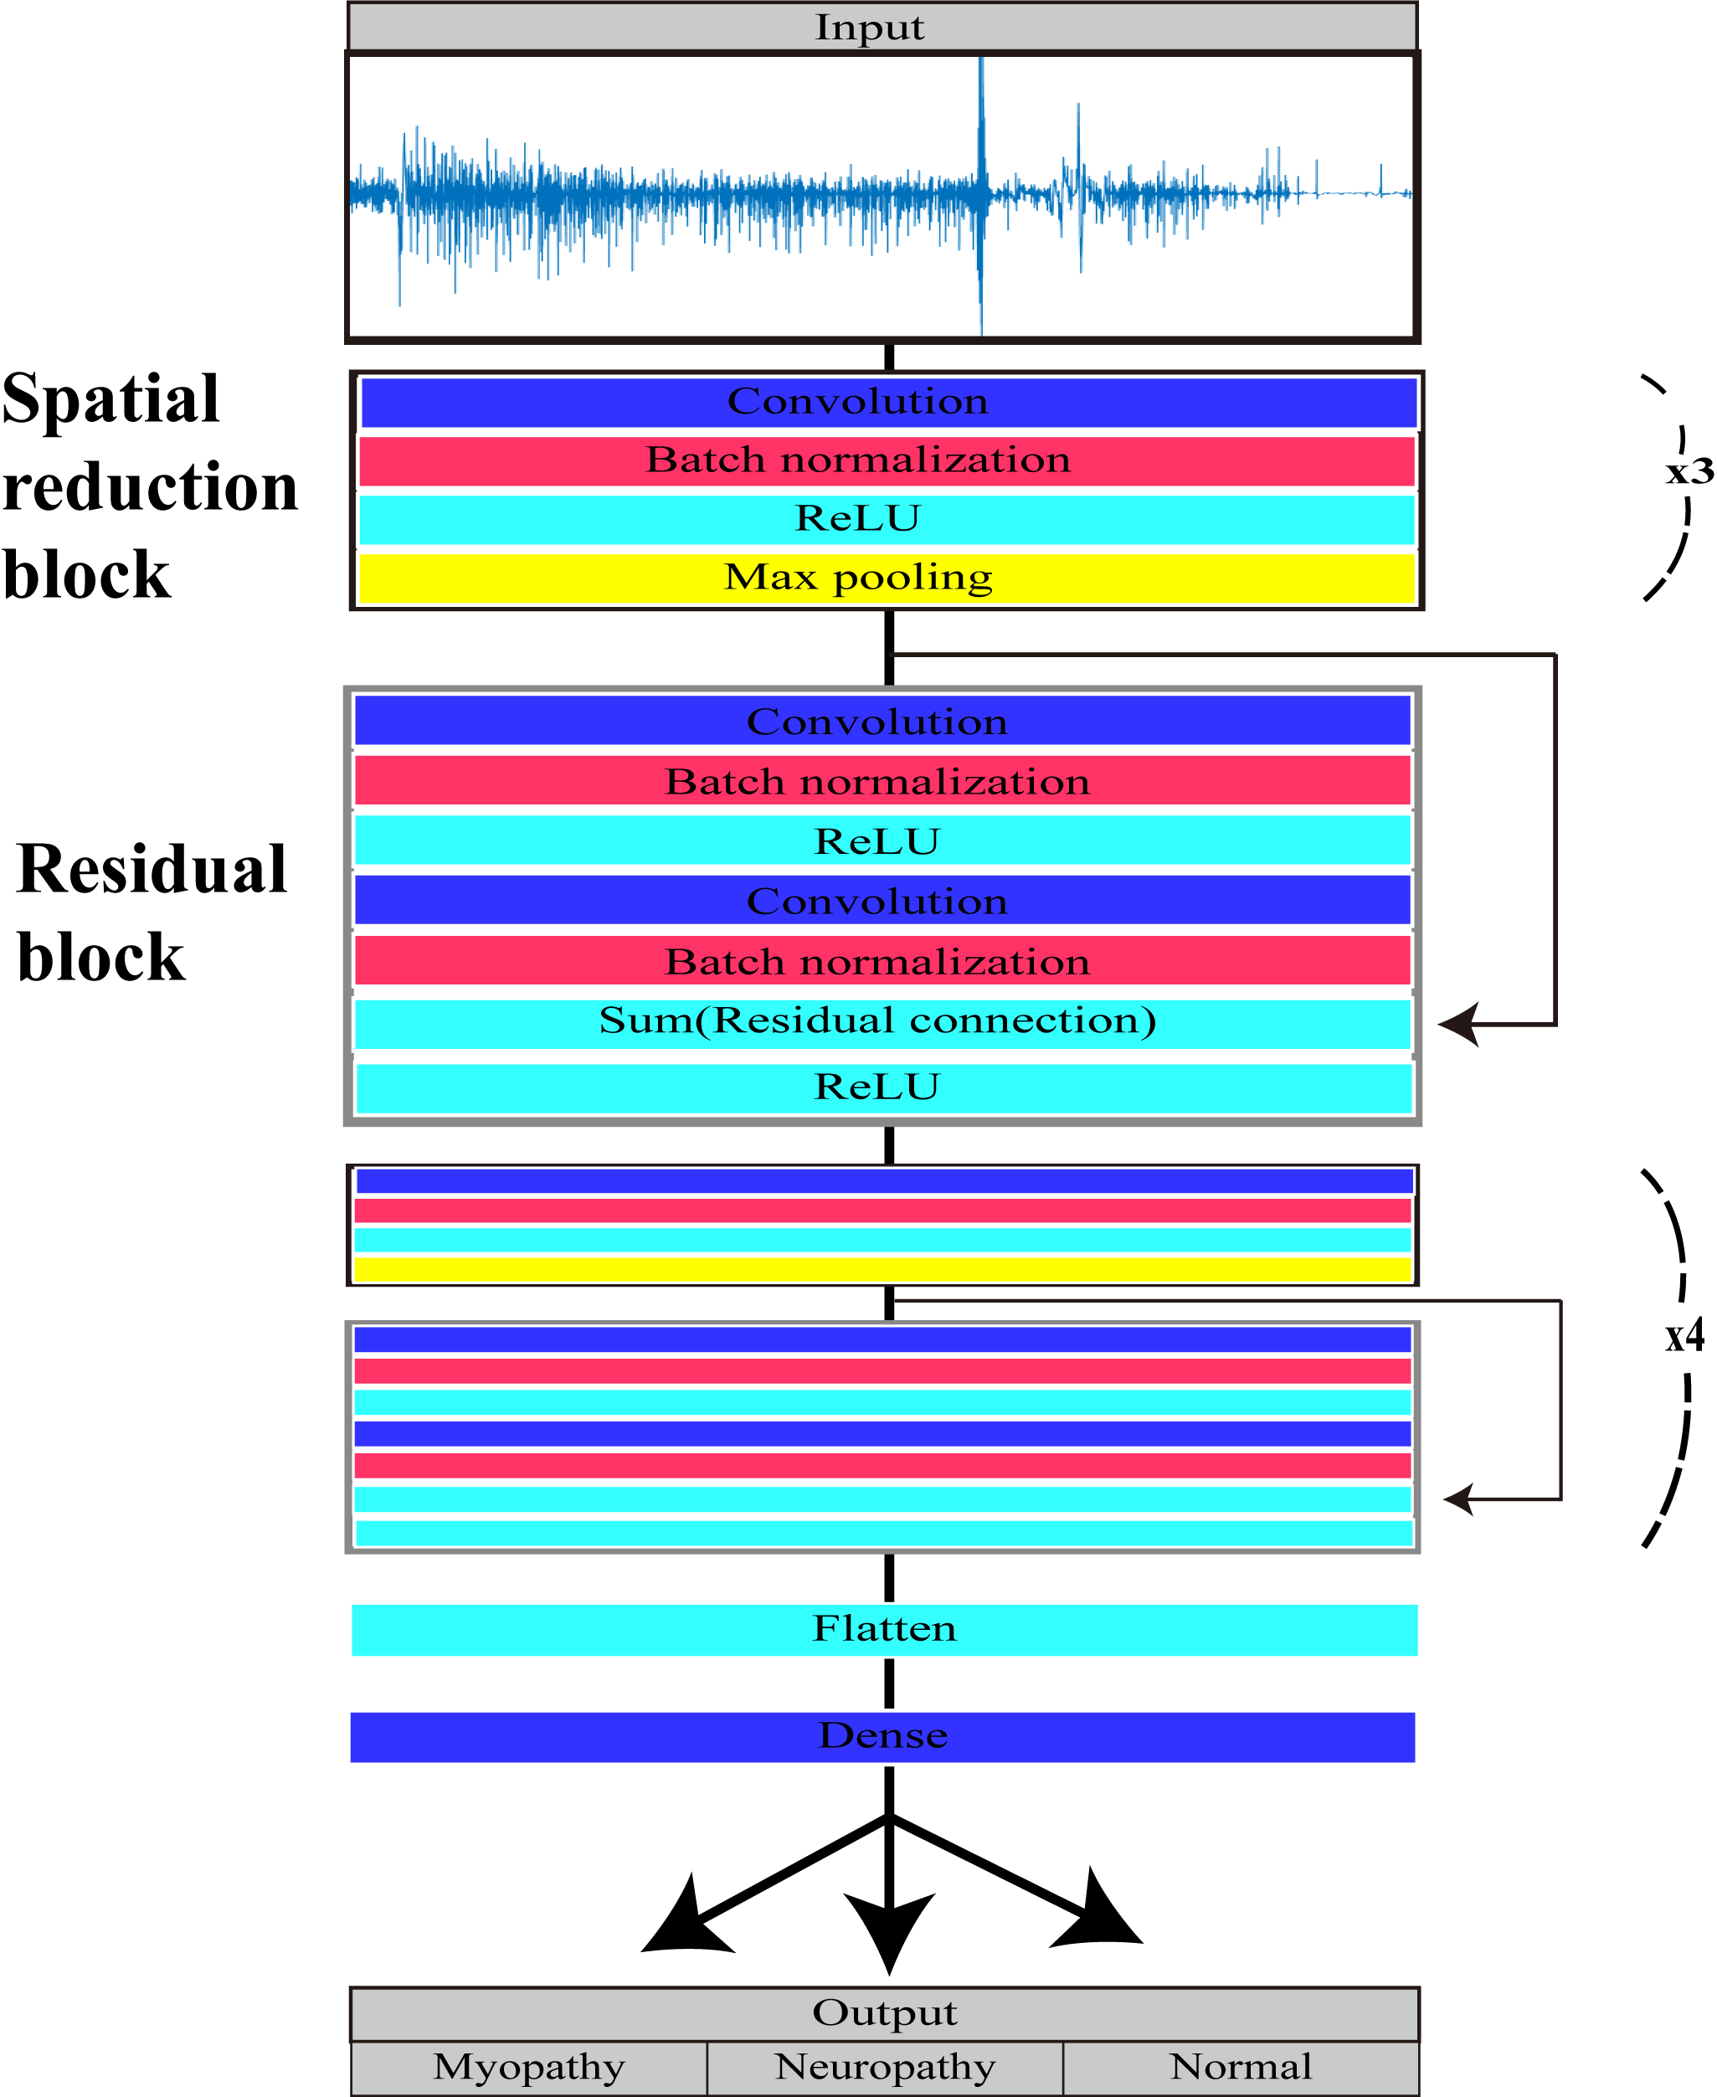

There are 7 spatial reduction blocks and 5 residual blocks with 1 and 2 convolutional layers, respectively

S3 Fig. Per-class receiver operating characteristics and precision-recall curves of the machine learning model with and without the muscle location information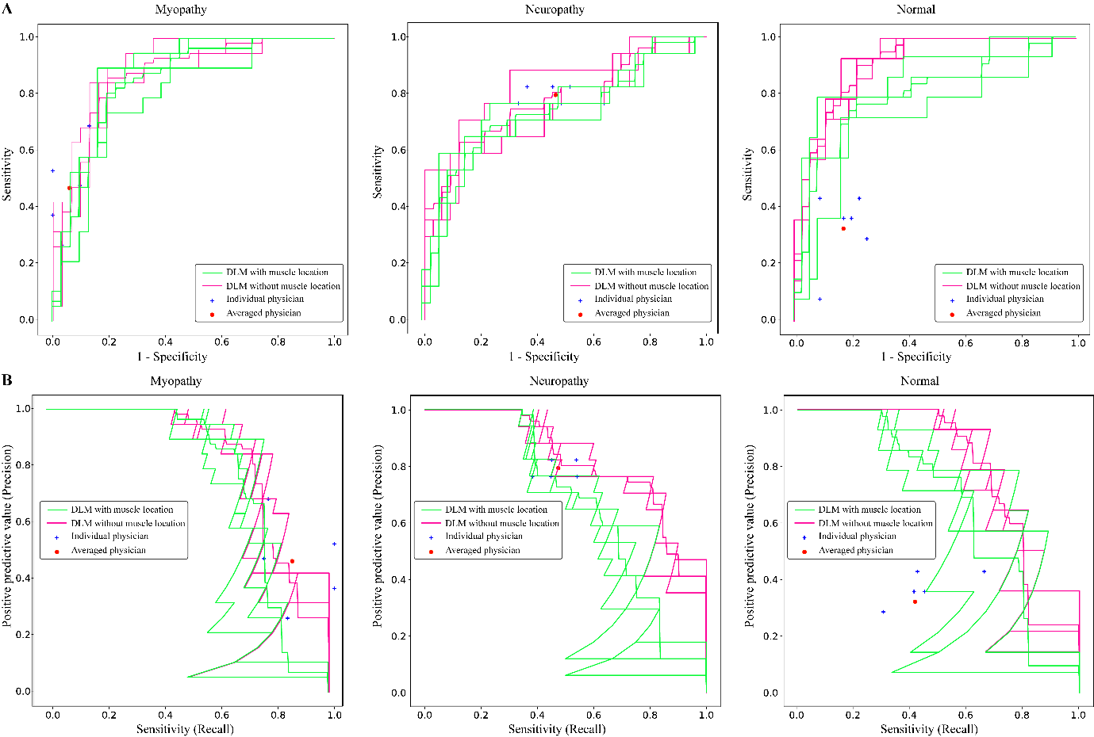

DLM = Deep learning model

The area under receiver operating characteristic curves (A) and precision-recall curves (B) were measured and depicted by dividing all data into myopathy, neuropathy, and normal.

Individual physician performance is annotated by the blue cross and averaged physician performance is annotated by the red dot.

ROC and precision-recall curves of the convolutional neural network algorithm depending on whether the muscle location information was considered (green lines, CNN with muscle location) or not (pink lines, CNN without muscle location).

S4 Fig. Confusion matrices of the machine learning model (A) without muscle location information and (B) with muscle location information

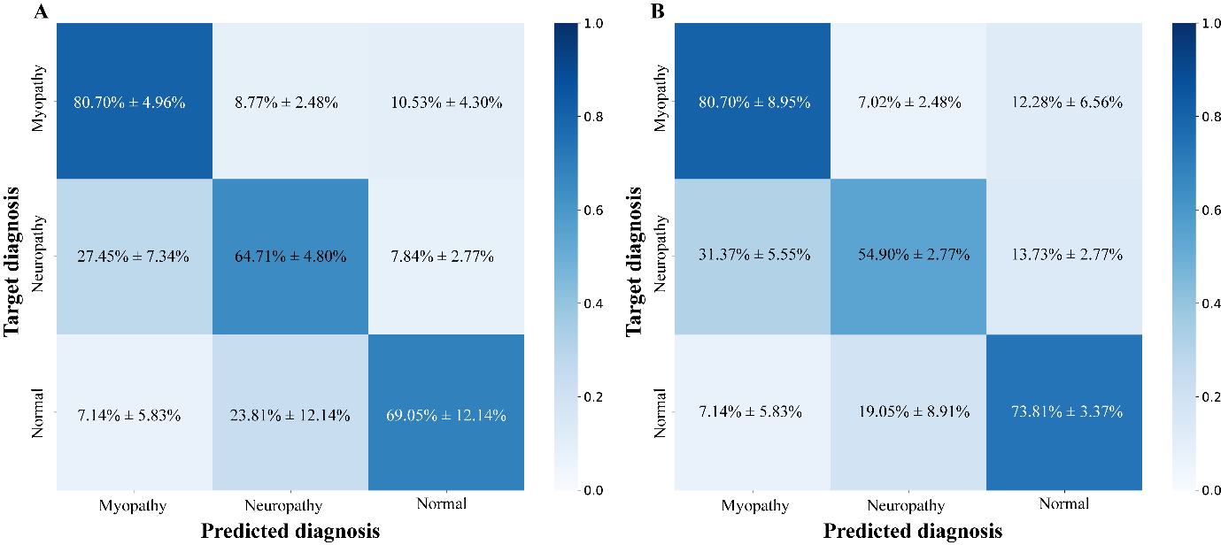

S5 Fig. Examples of electromyographic signals mispredicted by the deep learning model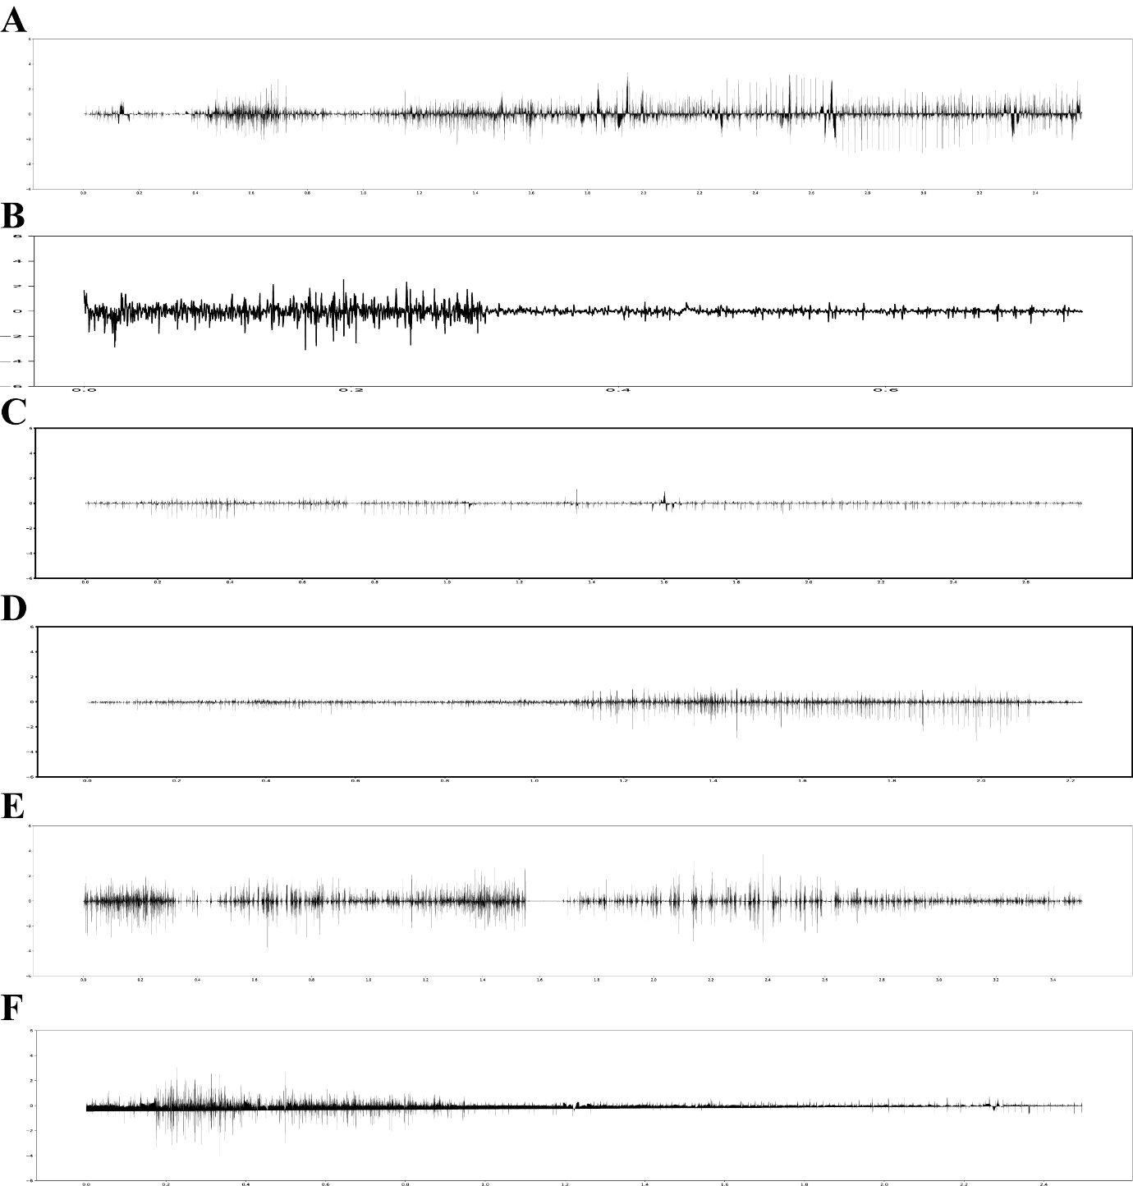

Electromyographic signal mispredicted (A) normal to neuropathy, (B) normal to myopathy, (C) neuropathy to myopathy, (D) neuropathy to normal, (E) myopathy to neuropathy, (F) myopathy to normal

**Author Contributions**

**Conceptualization**: Ilhan Yoo, Sung-Min Kim, Keewon Kim.

**Data curation**: Ilhan Yoo, Ina Youn, Hyodong Kim, Michelle Youn, Jun Hee Won, Cho Woosup, Youho Myong, Kim sehoon, Keewon Kim.

**Formal analysis**: Jaesung Yoo, Seung-Bo Lee.

**Funding acquisition**: no.

**Investigation**: Ilhan Yoo, Jaesung Yoo, Seung-Bo Lee, Keewon Kim.

**Methodology**: Kwangsoo Kim, Ri Yu, Seung-Bo Lee, Jaesung Yoo.

**Project administration**: Keewon Kim.

**Resources**: Keewon Kim.

**Software**: Jaesung Yoo, Dongmin Kim.

**Supervision**: Keewon Kim, Seung-Bo Lee.

**Validation**: Ilhan Yoo, Jaesung Yoo, Keewon Kim, Seung-Bo Lee.

**Visualization**: Ilhan Yoo, Jaesung Yoo.

**Writing – original draft**: Ilhan Yoo.

**Writing – review & editing**: Jaesung Yoo, Keewon Kim, Seung-Bo Lee,

**Abbreviations**

nEMG, needle electromyography; CNN, convolutional neural network; CI, confidence interval; EMG, electromyography; ReLU, rectified linear unit; AUROC, area under receiver operating characteristic curve; PPV, positive predictive value; ROC, receiver operating characteristic

**References**

1. Daube JR, Rubin DI. Needle electromyography. Muscle Nerve. 2009;39(2):244-70. Epub 2009/01/16. doi: 10.1002/mus.21180. PubMed PMID: 19145648.

2. Kimura J. Electrodiagnosis in Diseases of Nerve and Muscle: Principles and Practice: Oxford University Press; 2013.

3. Mills KR. The basics of electromyography. J Neurol Neurosurg Psychiatry. 2005;76(suppl 2):ii32-ii5. doi: 10.1136/jnnp.2005.069211.

4. Oh SJ. Clinical Electromyography: Nerve Conduction Studies: Lippincott Williams & Wilkins; 2003.

5. Rubin DI. Needle electromyography: Basic concepts. Handb Clin Neurol. 2019;160:243-56. Epub 2019/07/07. doi: 10.1016/b978-0-444-64032-1.00016-3. PubMed PMID: 31277852.

6. Whittaker RG. The fundamentals of electromyography. Pract Neurol. 2012;12(3):187-94. Epub 2012/06/05. doi: 10.1136/practneurol-2011-000198. PubMed PMID: 22661353.

7. Aminoff MJ, Goodin DS, Parry GJ, Barbaro NM, Weinstein PR, Rosenblum ML. Electrophysiologic evaluation of lumbosacral radiculopathies: electromyography, late responses, and somatosensory evoked potentials. Neurology. 1985;35(10):1514-8. Epub 1985/10/01. doi: 10.1212/wnl.35.10.1514. PubMed PMID: 2993952.

8. Bromberg MB. The motor unit and quantitative electromyography. Muscle Nerve. 2020;61(2):131-42. Epub 2019/10/04. doi: 10.1002/mus.26718. PubMed PMID: 31579956.

9. Gerardo Gutiérrez Gutiérrez CBLFNAMM. Use of Electromyography in the Diagnosis of Inflammatory Myopathies. Reumatología Clínica (English Edition). 2012;8(4):195-200. doi: 10.1016/j.reumae.2011.10.004.

10. Leblhuber F, Reisecker F, Boehm-Jurkovic H, Witzmann A, Deisenhammer E. Diagnostic value of different electrophysiologic tests in cervical disk prolapse. Neurology. 1988;38(12):1879-. doi: 10.1212/wnl.38.12.1879.

11. Sawada K, Horii M, Imoto D, Ozaki K, Toyama S, Saitoh E, et al. Usefulness of Electromyography to Predict Future Muscle Weakness in Clinically Unaffected Muscles of Polio Survivors. PM R. 2020;12(7):692-8. Epub 2019/11/09. doi: 10.1002/pmrj.12281. PubMed PMID: 31702870.

12. Tonzola RF, Ackil AA, Shahani BT, Young RR. Usefulness of electrophysiological studies in the diagnosis of lumbosacral root disease. Ann Neurol. 1981;9(3):305-8. Epub 1981/03/01. doi: 10.1002/ana.410090317. PubMed PMID: 6261675.

13. Paganoni S, Amato A. Electrodiagnostic evaluation of myopathies. Phys Med Rehabil Clin N Am. 2013;24(1):193-207. Epub 2012/10/16. doi: 10.1016/j.pmr.2012.08.017. PubMed PMID: 23177039.

14. Meekins GD, So Y, Quan D. American Association of Neuromuscular & Electrodiagnostic Medicine evidenced-based review: use of surface electromyography in the diagnosis and study of neuromuscular disorders. Muscle Nerve. 2008;38(4):1219-24. doi: 10.1002/mus.21055. PubMed PMID: 18816611.

15. Merletti R, Farina D. Analysis of intramuscular electromyogram signals. Philos Trans A Math Phys Eng Sci. 2009;367(1887):357-68. doi: doi:10.1098/rsta.2008.0235.

16. Haig AJ, Tong HC, Yamakawa KS, Quint DJ, Hoff JT, Chiodo A, et al. The sensitivity and specificity of electrodiagnostic testing for the clinical syndrome of lumbar spinal stenosis. Spine (Phila Pa 1976). 2005;30(23):2667-76. Epub 2005/12/02. doi: 10.1097/01.brs.0000188400.11490.5f. PubMed PMID: 16319753.

17. Kendall R, Werner RA. Interrater reliability of the needle examination in lumbosacral radiculopathy. Muscle Nerve. 2006;34(2):238-41. Epub 2006/04/13. doi: 10.1002/mus.20554. PubMed PMID: 16609977.

18. Nirkko AC, Rösler KM, Hess CW. Sensitivity and specificity of needle electromyography: a prospective study comparing automated interference pattern analysis with single motor unit potential analysis. Electroencephalogr Clin Neurophysiol. 1995;97(1):1-10. Epub 1995/02/01. doi: 10.1016/0924-980x(94)00248-6. PubMed PMID: 7533715.

19. Arthur KC, Calvo A, Price TR, Geiger JT, Chiò A, Traynor BJ. Projected increase in amyotrophic lateral sclerosis from 2015 to 2040. Nat Commun. 2016;7(1):12408. doi: 10.1038/ncomms12408.

20. Longinetti E, Fang F. Epidemiology of amyotrophic lateral sclerosis: an update of recent literature. Curr Opin Neurol. 2019;32(5):771-6. doi: 10.1097/WCO.0000000000000730. PubMed PMID: 31361627.

21. Parker MJS, Oldroyd A, Roberts ME, Ollier WE, New RP, Cooper RG, et al. Increasing incidence of adult idiopathic inflammatory myopathies in the City of Salford, UK: a 10-year epidemiological study. Rheumatol Adv Pract. 2018;2(2). doi: 10.1093/rap/rky035.

22. Rose L, McKim D, Leasa D, Nonoyama M, Tandon A, Bai YQ, et al. Trends in incidence, prevalence, and mortality of neuromuscular disease in Ontario, Canada: A population-based retrospective cohort study (2003-2014). PLoS One. 2019;14(3):e0210574. doi: 10.1371/journal.pone.0210574.

23. Alfaras M, Soriano MC, Ortín S. A Fast Machine Learning Model for ECG-Based Heartbeat Classification and Arrhythmia Detection. Front Phys. 2019;7(103). doi: 10.3389/fphy.2019.00103.

24. Lu X, Wu Y, Yan R, Cao S, Wang K, Mou S, et al., editors. Pulse waveform analysis for pregnancy diagnosis based on machine learning. 2018 IEEE 3rd Adv. Inf. Technol. Electron. Autom. Control Conf. IAEAC 2018.

25. Gemein LAW, Schirrmeister RT, Chrabąszcz P, Wilson D, Boedecker J, Schulze-Bonhage A, et al. Machine-learning-based diagnostics of EEG pathology. Neuroimage. 2020;220:117021. doi: https://doi.org/10.1016/j.neuroimage.2020.117021.

26. Roy Y, Banville H, Albuquerque I, Gramfort A, Falk TH, Faubert J. Deep learning-based electroencephalography analysis: a systematic review. J Neural Eng. 2019;16(5):051001. doi: 10.1088/1741-2552/ab260c.

27. Bien N, Rajpurkar P, Ball RL, Irvin J, Park A, Jones E, et al. Deep-learning-assisted diagnosis for knee magnetic resonance imaging: Development and retrospective validation of MRNet. PLoS Med. 2018;15(11):e1002699. doi: 10.1371/journal.pmed.1002699.

28. Hannun AY, Rajpurkar P, Haghpanahi M, Tison GH, Bourn C, Turakhia MP, et al. Cardiologist-level arrhythmia detection and classification in ambulatory electrocardiograms using a deep neural network. Nat Med. 2019;25(1):65-9. doi: 10.1038/s41591-018-0268-3.

29. Rajpurkar P, Irvin J, Ball RL, Zhu K, Yang B, Mehta H, et al. Deep learning for chest radiograph diagnosis: A retrospective comparison of the CheXNeXt algorithm to practicing radiologists. PLoS Med. 2018;15(11):e1002686. doi: 10.1371/journal.pmed.1002686.

30. Ribeiro AH, Ribeiro MH, Paixão GMM, Oliveira DM, Gomes PR, Canazart JA, et al. Automatic diagnosis of the 12-lead ECG using a deep neural network. Nat Commun. 2020;11(1):1760. doi: 10.1038/s41467-020-15432-4.

31. Akef Khowailed I, Abotabl A. Neural muscle activation detection: A deep learning approach using surface electromyography. J Biomech. 2019;95:109322. doi: https://doi.org/10.1016/j.jbiomech.2019.109322.

32. Atzori M, Cognolato M, Müller H. Deep Learning with Convolutional Neural Networks Applied to Electromyography Data: A Resource for the Classification of Movements for Prosthetic Hands. Front Neurorobot. 2016;10:9-. doi: 10.3389/fnbot.2016.00009. PubMed PMID: 27656140.

33. Nam S, Sohn MK, Kim HA, Kong H-J, Jung I-Y. Development of Artificial Intelligence to Support Needle Electromyography Diagnostic Analysis. Healthc Inform Res. 2019;25(2):131-8. Epub 2019/04/30. doi: 10.4258/hir.2019.25.2.131. PubMed PMID: 31131148.

34. Nodera H, Osaki Y, Yamazaki H, Mori A, Izumi Y, Kaji R. Deep learning for waveform identification of resting needle electromyography signals. Clin Neurophysiol. 2019;130(5):617-23. Epub 20190223. doi: 10.1016/j.clinph.2019.01.024. PubMed PMID: 30870796.

35. Wei W, Dai Q, Wong Y, Hu Y, Kankanhalli M, Geng W. Surface-Electromyography-Based Gesture Recognition by Multi-View Deep Learning. IEEE Trans Biomed Eng. 2019;66(10):2964-73. doi: 10.1109/TBME.2019.2899222.

36. Krizhevsky A, Sutskever I, Hinton GE. Imagenet classification with deep convolutional neural networks. Adv Neural Inf Process Syst. 2012;25.

37. He K, Zhang X, Ren S, Sun J, editors. Deep Residual Learning for Image Recognition. 2016 IEEE Conference on Computer Vision and Pattern Recognition (CVPR); 2016 27-30 June 2016.

38. Simonyan K, Zisserman A. Very Deep Convolutional Networks for Large-Scale Image Recognition. arXiv 14091556. 2014.

39. Prechelt L. Early Stopping - But When? In: Orr GB, Müller K-R, editors. Neural Networks: Tricks of the Trade. Berlin, Heidelberg: Springer Berlin Heidelberg; 1998. p. 55-69.

40. Olah C, Mordvintsev A, Schubert L. Feature visualization. Distill. 2017;2(11):e7. doi: 10.23915/distill.00007.

41. Haig AJ, Gelblum JB, Rechtien JJ, Gitter AJ. Technology assessment: the use of surface EMG in the diagnosis and treatment of nerve and muscle disorders. Muscle Nerve. 1996;19(3):392-5. doi: 10.1002/(sici)1097-4598(199603)19:3<392::Aid-mus21>3.0.Co;2-t. PubMed PMID: 8606710.

42. Logigian EL, Ciafaloni E, Quinn LC, Dilek N, Pandya S, Moxley RT, 3rd, et al. Severity, type, and distribution of myotonic discharges are different in type 1 and type 2 myotonic dystrophy. Muscle Nerve. 2007;35(4):479-85. doi: 10.1002/mus.20722. PubMed PMID: 17230537.

43. Dimachkie MM, Barohn RJ. Distal myopathies. Neurol Clin. 2014;32(3):817-x. Epub 2014/05/15. doi: 10.1016/j.ncl.2014.04.004. PubMed PMID: 25037092.

44. Carey IM, Banchoff E, Nirmalananthan N, Harris T, Dewilde S, Chaudhry UAR, et al. Prevalence and incidence of neuromuscular conditions in the UK between 2000 and 2019: A retrospective study using primary care data. PLoS One. 2021;16(12):e0261983. doi: 10.1371/journal.pone.0261983.

45. Hobson-Webb LD, Dearmey S, Kishnani PS. The clinical and electrodiagnostic characteristics of Pompe disease with post-enzyme replacement therapy findings. Clin Neurophysiol. 2011;122(11):2312-7. Epub 20110513. doi: 10.1016/j.clinph.2011.04.016. PubMed PMID: 21570905.